

***TOPIC:******LAPTOP REQUEST CATALOG ITEM***

|  |  |
| --- | --- |
| **NAME** | **REGISTER NO** |
| **K.MAGESHWARI** | **222308149** |
| **M.MANOJ KUMAR** | **222308132** |
| **P.SURYA** | **222308140** |
| **V.D.PAVITHRA** | **222308158** |

***PROJECT REPORT***

***Submitted by***

**In partial fulfillment for the award of the degree**

**Of**

**BACHELOR OF SCIENCE**

**IN**

**COMPUTER SCIENCE**

**SHREE CHANDRAPRABHU JAIN COLLEGE**

**MINJUR**

**SEP 2025**

*LAPTOP REQUEST CATALOG ITEM USING SERIVCENOW*

***Introduction:***

**A Laptop Request Catalog Item in ServiceNow allows employees to easily request a new laptop or replacement device through the Service Catalog. Instead of sending manual emails or contacting IT support, users can simply open the catalog, fill in the required details (such as laptop model, justification, and accessories), and submit the request.**

**This process standardizes laptop requests, ensures all necessary approvals are captured, and allows IT teams to track and fulfill requests efficiently. By using ServiceNow, organizations can automate approvals, improve transparency, and reduce delays in providing laptops to employees.**

***Objectives:***

**The main objectives of creating a Laptop Request Catalog Item in ServiceNow are:**

* **Simplify Laptop Requests: Provide employees with an easy-to-use form for requesting laptops.**
* **Standardize the Process: Ensure all requests follow the same format and collect all required information.**
* **Automate Approvals: Route requests automatically to managers or IT teams for faster approval.**
* **Improve Tracking: Allow users and IT teams to track the status of laptop requests in real time.**
* **Reduce Manual Work: Eliminate the need for emails, phone calls, and manual request handling.**
* **Enhance Transparency: Maintain a record of who requested, approved, and fulfilled the laptop request.**

***Features*:**

**1. Self-Service Request:**

**Employees can request a laptop anytime through the Service Portal without contacting IT manually.**

**2. Pre-Defined Laptop Models:**

**List of available laptops (basic, standard, high-performance) with specifications for easy selection.**

***3. Dynamic Form Fields:***

**Fields like Business Justification, Delivery Location, Cost Center auto-populate or show dynamically based on user profile.**

***4. Approval Workflow:***

**Automatically triggers approval from manager or department head before order is processed.**

***5. Automatic Task Creation:***

**Creates tasks for IT procurement, asset management, and fulfillment teams after approval.**

**6. Integration with Asset Management:**

**Links with CMDB (Configuration Management Database) to update inventory once the laptop is assigned.**

**7. Email & Notification Alerts:**

**Sends updates to requester and approver at each step (approval pending, approved, dispatched, delivered).**

**8. SLA Tracking:**

**Monitors request fulfillment time and ensures laptops are delivered within defined Service Level Agreements.**

**9. Cost Visibility:**

**Displays estimated cost of the laptop and charges to cost center if required.**

***10. Mobile & Portal Access:***

**Employees can raise and track requests from mobile, tablet, or desktop.**

***11. Reporting & Analytics:***

**Managers can track number of requests, fulfillment time, and spending trends.**

**12. User-Friendly Interface:**

**Simple, guided workflow with drop-downs, checkboxes, and descriptions to reduce errors.**

***Tools Used:***

* **The following tools were used to create and configure the Laptop Request Catalog Item in ServiceNow:**
* **ServiceNow Platform – Used to design and configure the catalog item, variables, and workflows.**
* **Update Set – Created to capture all configuration changes and move them safely between instances if required.**
* **Flow Designer / Workflow Editor – Used to create the approval flow and automate fulfillment tasks.**
* **Test Data – Sample user accounts and request data used to test the catalog item before going live**

***IMPLEMENTATION STEPS:***

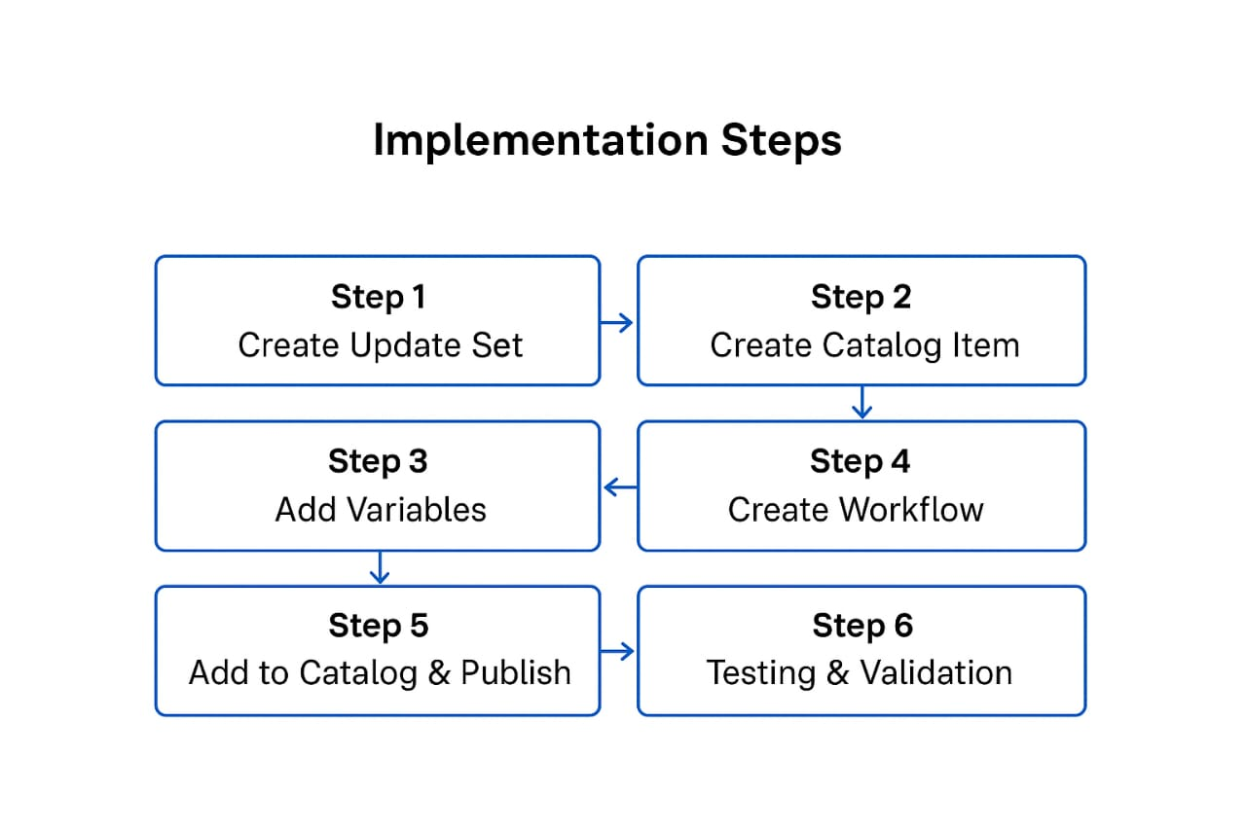

**Follow these steps to create a Laptop Request Catalog Item in ServiceNow:**

**Step 1: Create Update Set**

* **Navigate to System Update Sets → Local Update Sets.**
* **Click New and create an update set to capture all configuration changes related to the laptop request.**

**This ensures changes can be moved safely between instances**.

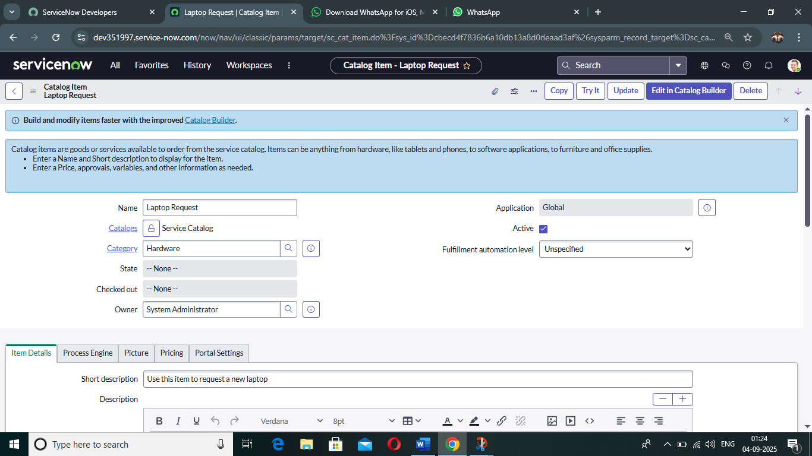

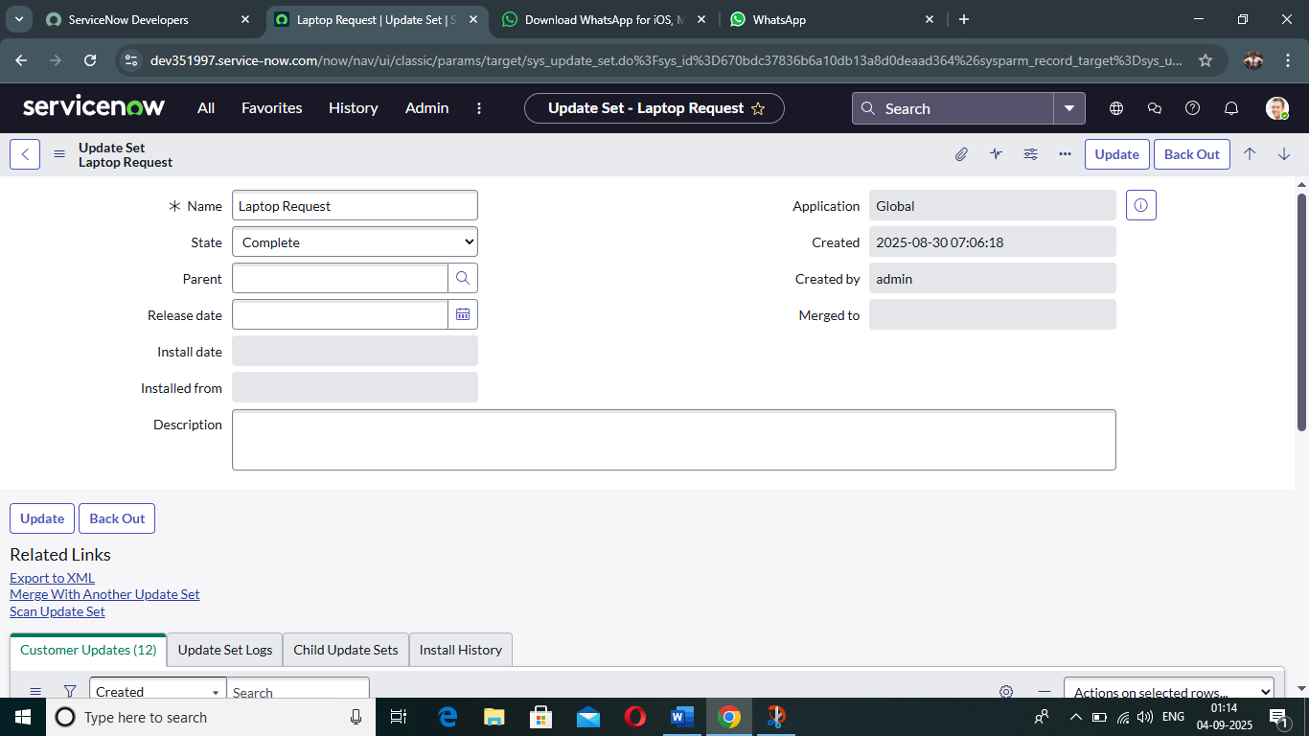

---

**Step 2:** **Create Catalog Item**

* **Go to Service Catalog → Catalog Definitions → Maintain Items.**
* **Click New and create a catalog item named Laptop Request.**
* **Add a description and select the appropriate category (e.g., Hardware).**

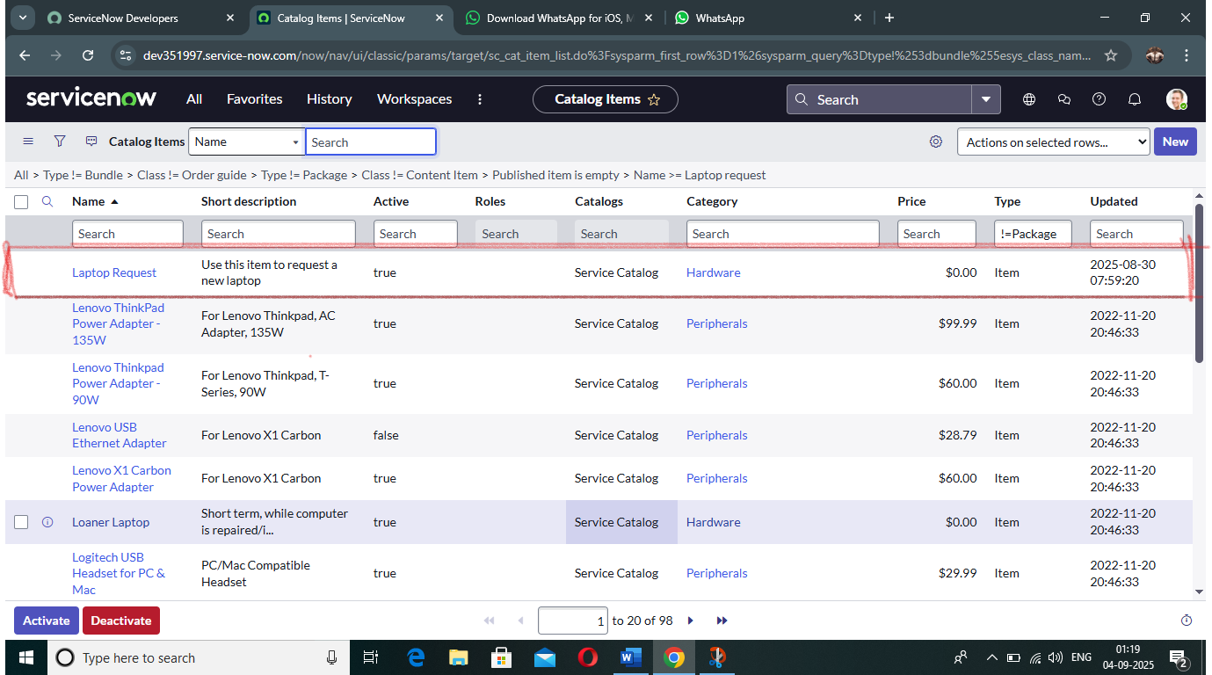

***Step 3:******Add Variables***

**Add required variables to the catalog item such as:**

* **Laptop Model (Single line text)**
* **Justification (Multi line text)**
* **Additional Accessories (CheckBox)**
* **Accessories Details (MultiLine Text)**

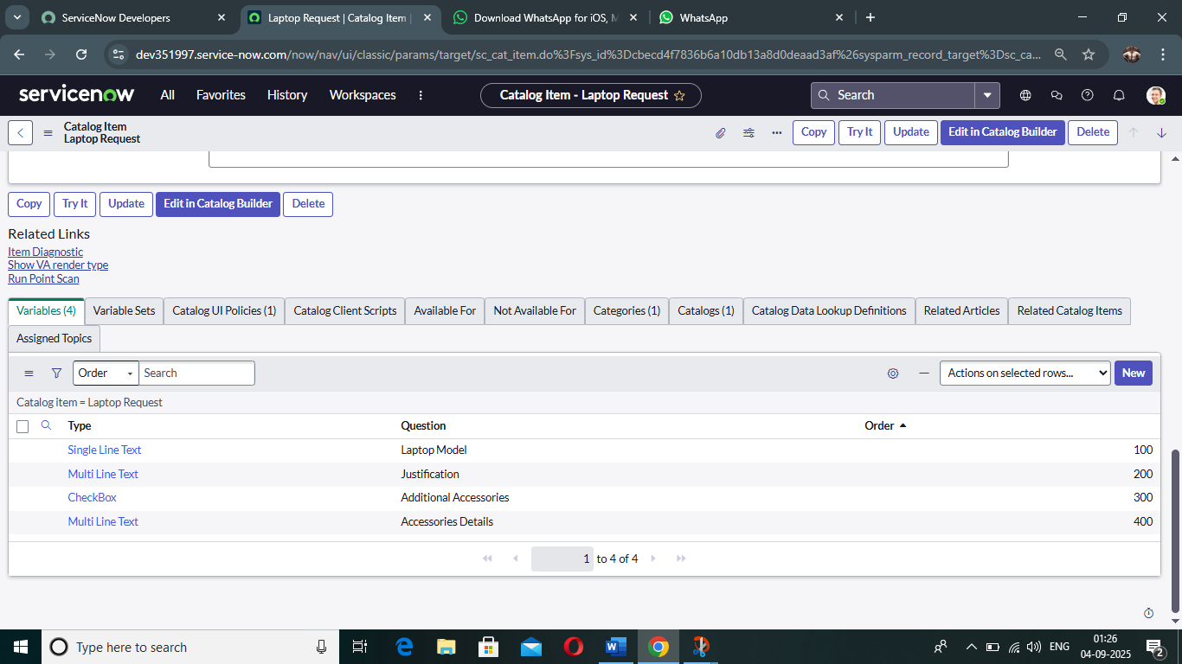

***Step 4*: Create Workflow / Flow Designer:**

* **Use Flow Designer or Workflow Editor to automate the process.**
* **Add approval step for Manager, task assignment to IT Fulfillment Team, and final fulfillment step.**

---

***Step 5: Add to Catalog & Publish***

* **Assign the catalog item to the right Service Catalog category so users can see it.**
* **Set Active = True and Publish the item.**

***Step 6: Testing & Validation***

* **Test the catalog item by submitting a sample request.**
* **Verify approval flow, fulfillment task creation, and request closure.**
* **Fix any issues before making it live for end users.**

***Workflow / Process Flow***

**The Laptop Request Workflow in ServiceNow automates the entire process of requesting and fulfilling a laptop. It ensures that all necessary approvals and tasks are completed before closing the request.**

***Workflow Steps:***

***1. User Submits Request:***

**Employee selects a laptop model, fills out justification, and submits the request from the Service Catalog.**

***2. Manager Approval:***

**The request is automatically routed to the employee’s manager for approval.**

**If rejected, the process stops and the user is notified.**

***3. IT Team Review:***

**After approval, the IT team receives a task to review the request and check laptop availability.**

***4. Laptop Procurement / Assignment:***

**If available, laptop is assigned from inventory.**

**If not available, procurement process is triggered to order a new one.**

***5. Fulfillment & Delivery:***

**Laptop is configured and delivered to the employee.**

**Request is marked as complete.**

***6. Closure & Notification:***

**The user receives a confirmation email that the request is fulfilled and closed.**

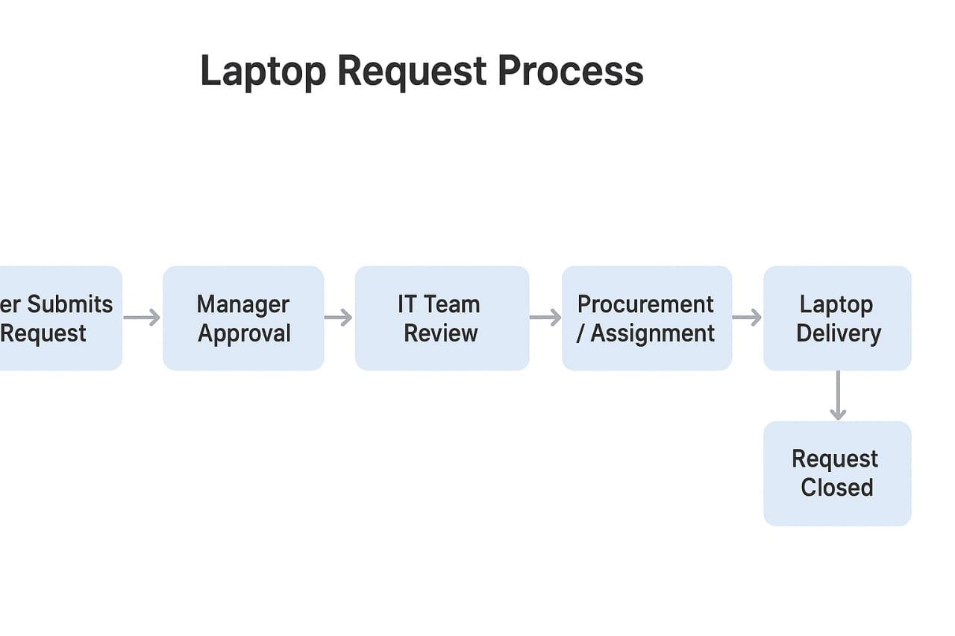

***Testing & Validation:***

**After configuring the Laptop Request Catalog Item, testing was performed to ensure the process works as expected from start to finish**

**Test Scenarios:**

|  |  |  |  |  |
| --- | --- | --- | --- | --- |
| ***Test Case*** | ***Input*** | ***Expected Result*** | ***Actual Result*** | ***Status*** |
| **1. Submit Laptop Request** | **User fills form with valid details** | **Request should be created successfully** | **Request created successfully** | **✅ Pass** |
| **2. Manager Approval** | **Manager receives approval notification** | **Request moves to IT team after approval** | **IT team received task** | **✅ Pass** |
| **3. IT Team Fulfillment** | **IT team assigns laptop from inventory** | **Task status should change to completed** | **Status changed correctly** | **✅ Pass** |
| **4. Request Closure** | **Laptop delivered** | **Request should auto-close and notify user** | **User received closure notification** | **✅ Pass** |
| **5. Invalid Input** | **Submit without mandatory fields** | **System should show error** | **Error message displayed** | **✅ Pass** |

***Validation Results:***

**The testing confirmed that the Laptop Request Catalog Item and workflow function as expected.**

**✅ All Test Cases Passed – No failures or errors observed during testing.**

**✅ Workflow Execution Successful – Approvals, task creation, and fulfillment worked correctly.**

**✅ Notifications Delivered – Users and managers received proper notifications at every stage.**

**✅ Data Captured Accurately – All mandatory fields stored correct information in the request record.**

**✅ System Performance Stable – Catalog item loaded quickly and processed requests without delay..**

**Benefits:**

**Creating a Laptop Request Catalog Item in ServiceNow provides several advantages for both employees and the IT team:**

**✅ Faster Request Submission – Users can easily submit laptop requests without sending emails or calling IT.**

**✅ Automated Approvals – Requests are automatically routed to managers for quick approval, reducing delays.**

✅ **Centralized Tracking – Both users and IT teams can monitor the status of requests in real time.**

**✅ Reduced Manual Work – Eliminates manual paperwork and follow-ups, saving time for IT and users.**

**✅ Better Data Accuracy – Mandatory fields ensure complete and correct information is collected every time.**

**✅ Improved User Experience – Simple and user-friendly interface encourages self-service.**

**✅ Audit & Compliance – All actions (request, approval, fulfillment) are recorded for future reference.**

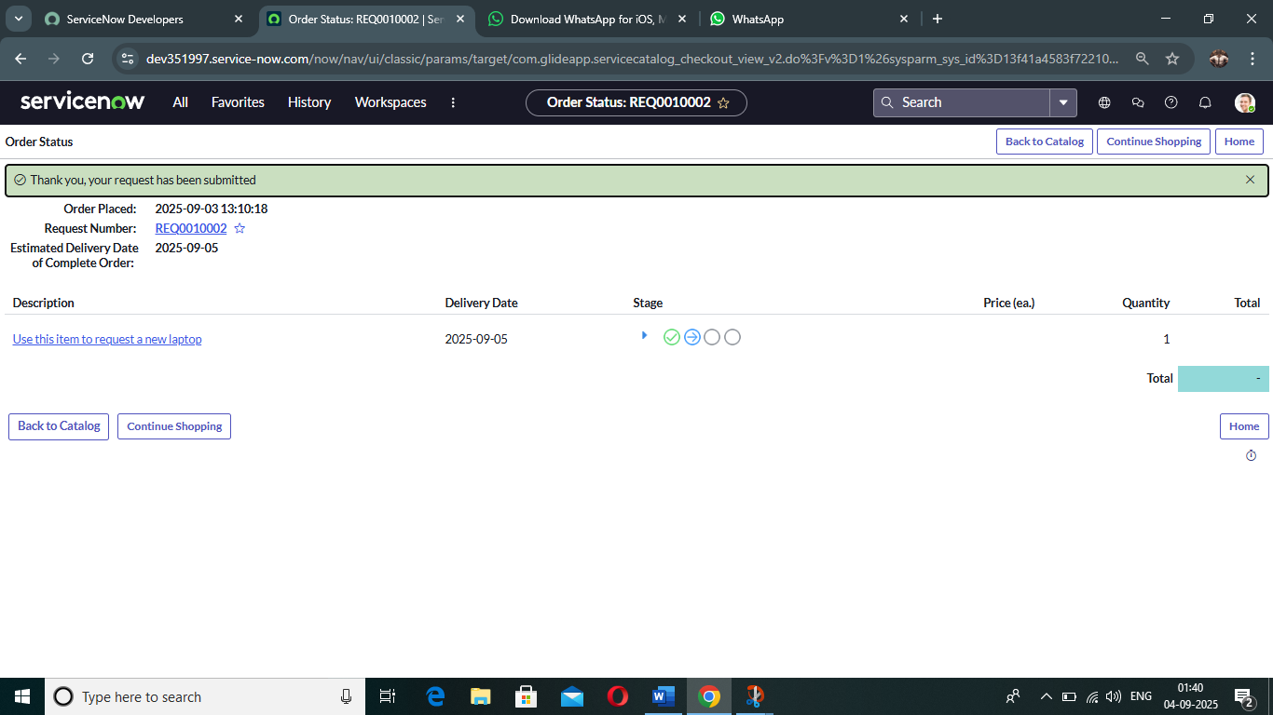

**Conclusion:**

**The Laptop Request Catalog Item created in ServiceNow provides a streamlined and automated way for employees to request laptops. By using a standardized form, automated approvals, and a clear fulfillment process, the solution improves efficiency, reduces manual work, and enhances transparency for both employees and IT teams.**

**With proper testing and validation, the workflow ensures that every request is handled correctly, from submission to fulfillment. This implementation not only saves time but also improves the overall user experience, making laptop requests faster, more accurate, and fully traceable.**

***THANK YOU***